LABORATORIYA ISHI 10

MAVZU: CSS Transition va Animatsiya Elementlarini Yaratish – Avia Kassa Loyihasi

1. Kirish
Web-ilovalarda foydalanuvchi tajribasini yaxshilash uchun animatsiyalar va vizual effektlar muhim rol o‘ynaydi. Avia kassa saytlarida foydalanuvchilar tez va qulay chiptalarni topishi, ularni tanlashi va xarid qilishi kerak. Shu sababli sahifadagi tugmalar, qidiruv formasi, chiptalar va menyu elementlari transition va animation yordamida silliq va jozibador ko‘rinishda bo‘lishi muhimdir.

2. CSS Transition

2.1 Transition tushunchasi
Transition — element holatlari o‘rtasidagi o‘zgarishlarni silliq va tabiiy ko‘rsatish imkonini beradi. Avia kassa sahifasida tugmalar, inputlar va chiptalar hover holatida sekin o‘zgarishi foydalanuvchi tajribasini yaxshilaydi.

2.2 Asosiy xususiyatlar
- transition-property: qaysi CSS xususiyati o‘zgarishini belgilaydi (background-color, transform).
- transition-duration: o‘zgarish davomiyligi (0.4s, 0.5s).
- transition-timing-function: o‘zgarish tezligi (ease-in-out, linear).
- transition-delay: o‘zgarish boshlanishini kechiktirish.

2.3 Afzalliklari
- Elementlar silliq o‘zgaradi.
- JavaScript ishlatmasdan animatsiya hosil bo‘ladi.
- Foydalanuvchi interfeysi jozibador bo‘ladi.

3. CSS Animation

3.1 Animation tushunchasi
Animation – elementlarni bir necha holatlar orqali ketma-ket harakatlantirish imkonini beradi. Avia kassa saytida chiptalar sahifaga kirishda ko‘tarilishi, fon gradientlari harakatlanishi yoki pop-up oynalar animatsiyali chiqishi mumkin.

3.2 Asosiy komponentlari
- @keyframes – animatsiya ketma-ketligini belgilash.
- animation-name – animatsiya nomi.
- animation-duration – davomiylik.
- animation-timing-function – harakat tezligi.
- animation-delay – boshlanish kechikishi.
- animation-iteration-count – takrorlanish.
- animation-direction – yo‘nalish.
- animation-fill-mode – animatsiya tugagandan keyin holat.

4. Transition va Animation farqlari
Xususiyat | Transition | Animation
Faollashish | Foydalanuvchi harakati bilan | Avtomatik yoki dasturlangan holatlarda
Murakkablik | Oddiy, bitta o‘zgarish | Murakkab, bir necha bosqichli
Boshlanish va tugash | Oddiy (hover, focus) | @keyframes yordamida boshqariladi
Takrorlanish | Yo‘q | Takrorlanuvchi bo‘lishi mumkin

5. Amaliy qism: Avia kassa sahifasi
<!DOCTYPE html>
<html lang="uz">
<head>
<meta charset="UTF-8">
<title>Avia Kassa – Transition & Animation</title>
<style>
/* ====== UMUMIY ====== */
body{
margin:0;
font-family:Arial, sans-serif;
background:linear-gradient(-45deg,#e3f2fd,#fce4ec,#e8f5e9,#fffde7);
background-size:400% 400%;
animation:bgMove 15s infinite alternate;
}
@keyframes bgMove{
0%{background-position:0% 50%}
100%{background-position:100% 50%}
}
/* ====== HEADER ====== */
header{
background:#0288d1;
color:white;
padding:20px;
text-align:center;
animation:headerDrop 1s ease;
}
@keyframes headerDrop{
from{transform:translateY(-50px);opacity:0}
to{transform:translateY(0);opacity:1}
}
/* ====== NAV ====== */
nav ul{
list-style:none;
display:flex;
justify-content:center;
gap:30px;
padding:0;
}
nav ul li a{
color:white;
text-decoration:none;
font-weight:bold;
transition:0.3s;
}
nav ul li a:hover{
color:#ffeb3b;
}
/* ====== SEARCH FORM ====== */
.search-form{
text-align:center;
padding:30px;
}
.search-form input, .search-form button{
padding:12px;
margin:5px;
font-size:16px;
border-radius:8px;
border:1px solid #ccc;
transition:0.3s;
}
.search-form input:focus{
border-color:#0288d1;
box-shadow:0 0 10px rgba(2,136,209,0.5);
}
.search-form button{
background:#0288d1;
color:white;
border:none;
cursor:pointer;
}
.search-form button:hover{
background:#026aa7;
transform:scale(1.05);
}
/* ====== TICKETS ====== */
.tickets{
display:flex;
justify-content:center;
flex-wrap:wrap;
gap:20px;
padding:20px;
}
.ticket{
width:250px;
background:white;
border-radius:16px;
box-shadow:0 6px 20px rgba(0,0,0,.2);
padding:20px;
text-align:center;
transition:0.4s;
animation:ticketUp 1s ease forwards;
}
.ticket:hover{
transform:scale(1.05);
box-shadow:0 10px 25px rgba(0,0,0,.3);
}
@keyframes ticketUp{
from{transform:translateY(40px);opacity:0}
to{transform:translateY(0);opacity:1}
}
/* ====== RESPONSIVE ====== */
@media(max-width:768px){
.tickets{flex-direction:column;align-items:center;}
nav ul{flex-direction:column;gap:15px;}
.search-form input, .search-form button{width:80%;}
}
</style>
</head>
<body>
<header>
<h1>✈️ Avia Kassa – Transition & Animation</h1>
<nav>
<ul>
<li><a href="#">Bosh sahifa</a></li>
<li><a href="#">Chiptalar</a></li>
<li><a href="#">Bog‘lanish</a></li>
</ul>
</nav>
</header>
<section class="search-form">
<input type="text" placeholder="Ketish shaharini kiriting">
<input type="text" placeholder="Yetib borish shaharini kiriting">
<input type="date">
<button>Qidirish</button>
</section>
<section class="tickets">
<div class="ticket">
<h3>Toshkent → Moskva</h3>
<p>Sanasi: 25/12/2025</p>
<p>Narx: 250$</p>
</div>
<div class="ticket">
<h3>Toshkent → Istanbul</h3>
<p>Sanasi: 26/12/2025</p>
<p>Narx: 180$</p>
</div>
<div class="ticket">
<h3>Toshkent → Dubay</h3>
<p>Sanasi: 27/12/2025</p>
<p>Narx: 300$</p>
</div>
</section>
</body>
</html>

NATIJA
- Header va menyu sahifaga kirishda animatsiya bilan paydo bo‘ladi.
- Qidiruv formasi hover va focus holatida rang va soya bilan jonlanadi.
- Chiptalar sahifaga kirishda ko‘tariladi va hover qilinganda kattalashadi, soya effektlari qo‘shiladi.
- Background gradient animatsiyali harakat qiladi.
- Telefon va planshetlar uchun responsiv dizayn mavjud.
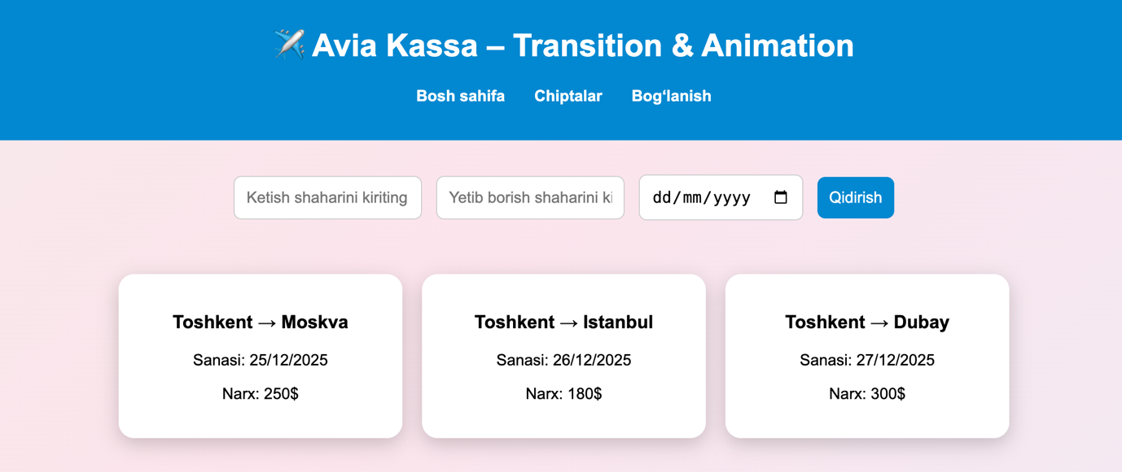

XULOS
CSS transition va animation yordamida Avia kassa sahifasidagi barcha interaktiv elementlar jonlandi. Foydalanuvchi tugmalar, inputlar va chiptalar bilan silliq va qulay tarzda o‘zaro aloqada bo‘lishi mumkin. Animatsiya va transition elementlari web-ilovalarni yanada interaktiv va professional ko‘rinishga olib keladi, foydalanuvchi tajribasini oshiradi.

